Melt-Processed Polymer Multilayer Distributed Feedback Lasers: Progress and Prospects
James H. Andrews¹, Michael Crescimanno¹, Kenneth D. Singer^{2,3}, Eric Baer³
Dept. of Physics & Astronomy, Youngstown State University, Youngstown, Ohio 44555 USA
Dept. of Physics, Case Western Reserve University, Cleveland, Ohio 44106 USA
Dept. of Macromolecular Science and Engineering, Case Western Reserve University, Cleveland, Ohio 44106 USA
Correspondence to: James H. Andrews (E-mail: jandrews@ysu.edu)
ABSTRACT
Reflecting recent progress in the functionalization of roll-to-roll processed polymer multilayers, this review describes the development and characterization of versatile large-area multilayer distributed feedback (DFB) lasers. These developments are reviewed in the broader context of microresonator lasers generally, with a brief tutorial on the theory and experiment needed to understand their unique features. Of these features, particular emphasis is placed on the broad tunability of these DFB lasers by simple modification of their structure, mechanical stretching, and temperature. Prospects and promises for commercialization of polymer multilayer DFB lasers is also discussed.
KEYWORDS: microresonator, distributed feedback laser, dye laser, co-extrusion, melt-processing, laser tuning

INTRODUCTION
Flexible polymeric thin film structures have received much attention as possible components of novel optical and photonic devices due to their tailored functionality, ease of processing, and amenability to large-area, low-cost fabrication. In particular, multilayer polymers, are being developed for filters, sensors, switches and optical limiters, data storage media, and, as highlighted in this review, lasers.
Typically, lasers combine three distinct system features, (i) an emissive gain media, which has an electronic structure suitable for amplified spontaneous emission (ASE) (such as a fluorescent dye), (ii) an optical resonator to enable the feedback necessary for stimulated emission and to control the spatial and spectral coherence of the beam (such as the spaced mirrors of a Fabry-Perot cavity, with at least one also serving as an output facet), and (iii) a pump source (such as another laser, flashlamps, light emitting diodes, or, if practicable, an electrical current) that excites electrons in the gain media into higher energy states from which stimulated emission is possible. This paper is focused on one such type of micro-resonator laser design, the multilayer distributed feedback (DFB) polymer laser. In DFB lasers (first called ‘mirrorless’ lasers), the first two aspects, the feedback mechanism and gain media, are integrated and distributed throughout the structure. In DFB lasers the circulation of ASE, or feedback leading to stimulated emission, within the structure arises from interference of multiple reflections (diffraction). Schematics comparing two designs, a Fabry-Perot laser with selectively reflective end mirrors and the multilayer DFB laser are shown in Figs. 1(a)-(b), respectively. Note that the mirrors in the former case may themselves be made from multilayers, as in distributed Bragg reflectors, leading to lasers called Distributed Bragg Reflector (DBR) lasers. Thus, in the DFB laser, the mirrors and the gain media share functionality, making possible a compact “micro-resonator.” Beyond compactness and, in some cases, simplifications in fabrication, DFB lasers require essentially no post-fabrication alignment and can more naturally operate in a single longitudinal mode, thereby producing narrower linewidths and better control. As we discuss in detail below, the distributed feedback design also enables tuning of the wavelength to the extent that the multilayer spacing, effective refractive index, and phase relationships can be adjusted in situ.

(c)
FIGURE 1 Schematics of a typical (a) Fabry-Perot cavity laser using wavelength selective mirrors (such as multilayer distributed Bragg mirrors), (b) simple multilayer DFB laser, and (c) folded ‘defect’ multilayer DFB laser with stepped center layer thickness.
Scope of Review
Multilayer vs. Corrugated Surface Grating DFBs
The scope of this review is limited to the study of polymer multilayer DFB lasers. The earliest and still most common distributed feedback designs are based on the use of gain media incorporated into corrugated surface diffraction gratings, rather than multilayers.⁸ Microfabrication techniques required for these submicron surface features date back to the first uses of holographic photolithography, but these were limited to the use of photoresists and required both a multistep process and a rigid flat surface. Over the past two decades, a wide variety of new techniques have been developed that have improved versatility and simplicity, such as e-beam lithography, embossing,¹⁰ and imprinting or replica molding., So-called soft-lithography, techniques can be used with elastomeric materials to stamp, mold, and otherwise micro-imprint the desired surface grating., These techniques still require multiple complex processing steps in the creation of the corrugated grating, apart from the introduction of the gain media through spin coating or other means, making them less amenable to mass production. Further, to the extent that corrugation techniques rely on elastomeric materials that are amenable to the soft lithography printing processes, they also tend to introduce distortions. A surface corrugated DFB structure produces edge emission when the lowest order diffraction is used, as in a waveguide, but high optical quality cleaved edges are difficult to achieve in amorphous polymers. Surface emission is possible using second-order grating effects, but with a higher threshold, typically by a factor of two, compared to first-order diffraction.
We focus here on a multilayer design that creates a two-dimensional surface for lasing, rather than edge emission or higher order surface emission common to corrugated grating systems. The melt-processed multilayers described and studied here are readily scalable for mass production of multilayer interference mirrors and DFB lasers, even over very large surface areas. These materials can form two-dimensional surface-emitting array lasers for parallel processing systems. For co-extruded multilayer DFB laser systems, there are exciting prospects for commercial applications due to their simplicity, low-cost, ease of processing, and flexibility as they continue improving toward the goal of matching or exceeding the lasing performance, low thresholds, and narrow linewidths of corrugated grating based DFB systems and other microresonator lasers.
Although a detailed review of DFB lasers using a corrugated surface grating design is beyond the scope of this review, many of the same considerations apply, particularly the theoretical analysis of the resonator structure further described below. A review of developments in corrugated surface grating-based DFB laser design, particularly those using organic semiconductors, can be found in Ref. []. For recent overviews of the broader scope of solid-state organic lasers, see also Refs. [7,] and the reviews cited therein.
Other Types of Organic DFB Laser Structures
Holographic Interference in Dichromate Gelatins
While holographic interference lithography techniques have been commonly employed to produce corrugated gratings for DFB lasers, it is worth mentioning that there are also specialized interference techniques that produce layered systems. The holographic interference layering process has, to date, been demonstrated only in high-resolution dichromate gelatin (DCG) emulsions, but has been successfully used to create simple DFB lasers and defect DFB lasers by superposition of two interference patterns with overlapping band edges. In DCG systems, the layered structure results from the interference of a shorter wavelength writing laser, dye diffusion into the gelatin through a swelling process followed by dehydration and baking and sealing. Resulting refractive indices created by the interference were on the order of 1.41 to 1.5, requiring a large number of layers for a high quality reflection band. Interestingly, in Ref. [26], the final emulsion layer spacing is not uniform throughout, but is graded in thickness, i.e., the layer spacings are narrower on one side of the film than the other. Graded multilayers have been shown to result in a widening of the bandgap,^{20,} and have recently been used to enable multi-wavelength DFB laser arrays.
Block Co-Polymers
In addition to the polymer forced-assembly technique described below, several mechanisms for self-assembly are being explored, such as the use of block co-polymers or co-polymer/homopolymer blends., Self-assembly of block co-polymers has been used for the multilayer step for distributed Bragg (DBR) reflectors, but requires specialized synthesis steps to obtain the desired layer thicknesses., Use of self-assembly for DFB lasers is more restrictive also because the process does not lend itself to large refractive index differences, large areas, and simultaneous optimization of the gain media in alternating layers of the self-assembled structure.²⁸
Chiral Liquid Crystals
Though not strictly all-polymer (but see refs. [,,]), a great deal of work has been done in the area of chiral liquid crystal DFB lasers,,,, wherein the multiple interference feedback structure is achieved through the spontaneous assembly of chiral nematic or chiral smectic periodic (helical) structure. Intermediate phases between smectic and nematic, called blue phases, are also found to form periodic structures with reflection bands. For a review of the tuning response of cholesteric liquid crystals, see ref. [].
The rest of this review is organized as follows. It is useful to relate the phenomena we describe below through a simple theoretical framework, so we first provide a brief tutorial on theoretical considerations in multilayer DBR and DFB laser microresonators along with issues related to the gain media used in these systems. We then describe forced assembly techniques used in fabricating multilayer polymer DFB lasers using melt-processed co-extrusion. We serially review work that exploits the versatility of these systems, focusing particularly on novel techniques for post-process tuning of multilayer polymer DFB lasers. Finally, we speculate on the prospects and promise of this type of laser for diverse applications.
MULTILAYER CAVITY DFB DESIGN/THEORY
One-Dimensional Photonic Bandgap Effects
In this section, we review some of the basic optical properties of the DFB structure in both band-edge and defect-mode lasing configurations. As first proposed and demonstrated at Bell Labs in 1971 by Kogelnik and Shank,⁸ the distributed feedback laser requires a periodic variation of either the refractive index or the gain profile or both. This periodic index alternation (which need not be strictly bimodal and may include significant regions of gradient refractive index between the layers or, indeed, even be sinusoidal⁸) produces a reflection band over a range of frequencies. A binary multilayer DFB resonator consists of alternating layers of two materials of contrasting refractive index , only one of which contains the gain media, in approximately quarter- wavelength optical thickness increments for j=1,2. (See Fig. 1(b),(c).) The first order free-space wavelength center () and spectral width of the reflection band of such a system of two materials with real indices and are thus given in the simple binary DFB system by:
(1)
. (2)
To model the resonator properties associated with a multilayer interference, one commonly represents each layer and interface by a characteristic transfer matrix describing the transmission/absorption/reflection through each layer/surface. The structure’s overall transmissive, reflective and absorptive properties (at normal incidence in the absence of birefringence or other polarization anisotropy) can be determined by the product of these transfer matrices, modified, if appropriate, to account for loss of coherence. (If birefringence is significant, the resonator structure can be modeled with matrices; see, for example, ref. []. For simplicity, however, we discuss the case of polarization preserving transport only.) Briefly, the linear relation between the amplitude of the fields in the j^{th} layer and those in the (j+1)^{th} layer can be represented using the Fresnel (complex) reflection and transmission coefficients in the matrix product
(3)
where and can parameterize either absorption loss or gain in the j^{th} layer. (For our present purposes, we ignore the gain dependence on the pump parameters, hysteresis, and other factors related to pulsed pumping.) The total system transfer matrix is thus:
(4)
and, for example, the overall transmittance of the laser resonator is simply expressed by .
The foregoing method models the theoretical transmission spectra for representative multilayer systems as shown by example in Fig. 2. Consistent with photonic crystal (PhC) terminology, the band gap is the region of low transmissivity (high spectral reflectivity). As predicted by Eqs. (1) and (2) and seen in Fig. 2(a), low refractive index contrast leads to a narrower band gap and the need for a larger number of layers to produce a higher contrast (sharper-edged) reflection band.
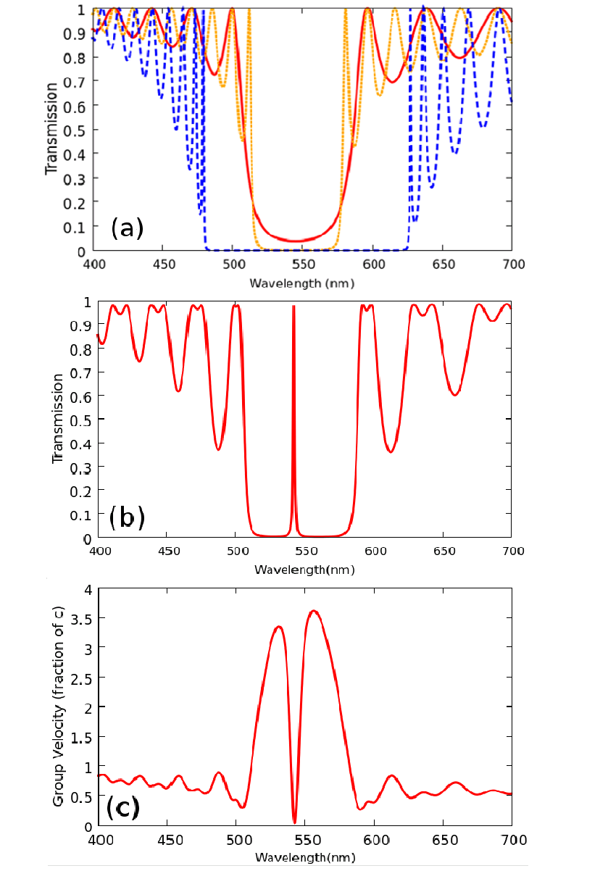
FIGURE 2 (a) Calculated transmission for multilayer system having 32 (solid line, red) or 64 (dashed, orange and dashed, blue) equal thickness layers and a = 0.17 (solid line and dotted) and a of 0.2 (dashed line), in order to illustrate the effects of the index contrast and number of layers on the reflection band, (b) Transmission , and (c) group velocity of a perfect 64 layer system, with a center "phase slip" defect created by simply folding a 32 layer film as described in the text. Note in (c) the pronounced decrease in the group velocity at the defect and band edge.
Extension of this transfer matrix technique to non-normal incidence is straightforward, but requires separate treatment for TE and TM incident light. Details of the calculation are left to the references,³⁹ but it is important to note that at non-normal incidence, regardless of polarization, the bandgap shifts towards shorter wavelengths. This fact becomes particularly relevant when optically pumping DFB lasers if there is only a small separation between the absorption and emission peaks of the gain media (small Stokes shift). One can use this angle tuning of the bandgap to increase the absorption of the pump light by shifting the reflection band away from the pump wavelength. Further studies of the effect of angle of incidence of the pump beam on a similar system can be found in ref. [] which also explores differences between low and high energy band edge.
Defect Structures
An interesting effect occurs when the periodic multilayer system is folded to create a defect (doubled) layer in the center of the stack. (See Fig. 1(c).) Figure 2(b) shows that the bandgap splits and a narrow transmission region appears near the center of the bandgap. This break from perfect periodicity in the multilayer is an example of what is called a “phase-slip defect” which results in one or more transmission defects in the reflection band.,, In a simply folded binary DFB system, the phase slip defect naturally appears as either a thicker half-wavelength region of low refractive or high refractive index in the center of the stack. Note that repeated folding or breaks in the periodicity of the structure lead to additional defect modes, which may be useful for a multiple wavelength ‘origami’ laser. Ref. [] also discusses the theory of cascaded phase-slips in a DFB resonator. For a single fold, differences in the resulting DFB laser behavior for these two different fold directions results from whether gain occurs in the low index or high index material. The performance of the resulting “defect” DFB laser is also strongly dependent on the location and width of the structural defect in the stack. As will be discussed below, some structure defects (for example, due to variations in the layer thicknesses) may not be completely avoidable, but their presence may also be advantageous for lowering the threshold and enabling tuning of the DFB laser.
Many excellent monographs are available for a more detailed discussion of the band structures generally of photonic crystals, with and without defect states. In addition to the citations above, see, for example, refs. [],[] and [].
Group Velocity Delay and Modeling with Gain
To connect the properties considered thus far with the physics of a DFB laser, it is instructive to consider how the multilayer micro-resonator structure effectively slows the propagation of light, increasing the light interaction with the medium and, equivalently, increasing the electric field energy locally in the multilayer. To understand how the structure will respond to the introduction of a gain media and pump source, it is useful to first calculate the density of states or, equivalently in one-dimension, the inverse group velocity . The group velocity can be obtained directly from the inverse slope of the phase retardation of the system. See, for example, ref. [] for a derivation of the group velocity in a bilayer system with full Bloch eigenfunctions. In an infinite well-ordered system, the group velocity vanishes as a power law at perfect band edges, implying increased light/matter interaction and consequently the potential for large gain. The rate of spontaneous emission at a particular frequency using Fermi’s Golden Rule is proportional to the density of states at that frequency.
To calculate the properties of the full DFB laser with gain, a variety of approaches can be used, such as coupled-wave theory and plane-wave eigenmode expansions. One particularly simple approach, taking advantage of the matrix formalism developed so far, is to assume a negative imaginary part to the refractive index representing gain. A more careful approach will use the finite time propagation of the pump pulse and the time dependence of the lasing field. In Dowling, et al.,⁵⁰ the effects of gain were determined directly by solving for pulse propagation according to the Maxwell wave equation,
(5)
where n(z) is the refractive index and g(z) the gain function throughout the stack. Practically, the solution to this equation for a finite structure is accomplished through a finite difference, time domain (FDTD) numerical technique. Details of the FDTD calculation can be found in ref. []. In this method, light emitting sources are simulated inside the stack to mimic the distribution of light emitting gain media (dye) inside the structure. The resulting light field is then allowed to propagate in accordance with Maxwell’s equations in a step wise fashion. The limitations of the method are derived from the need for small time steps and a fine spatial grid, and one must take particular care at the discontinuous dielectric interfaces, e.g., layer boundaries. Obviously, this method can be calculation intensive, but many efficient numerical packages exist to facilitate the computation process.,
Regardless of the method used, the periodic index variations of these multilayers leads to a pulse-limited, quasi-standing wave inside the film, with the buildup of field intensity inside the film enhanced several times over the maximum input field intensity. Effectively, the structure can be designed to use interference to pile up energy in the antinodes, where it can be absorbed by the gain medium there. The location of these antinodes is function of wavelength, appearing in the high refractive index material on the long wavelength edge of the bandgap and in the lower refractive index material on the shorter wavelength bandgap edge. Thus, whether the lasing threshold is preferred at the high-energy or the low-energy edge of the reflection band depends upon whether the gain medium is in the lower refractive index or higher refractive index constituent, respectively, as illustrated in Fig. 3.⁵⁶
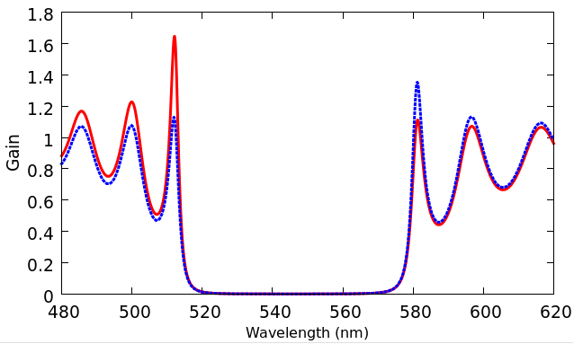FIGURE 3 A computation of the transmitted signal (incident signal of unit intensity) through 64 equal thickness layers of a binary DFB (indices of refraction 1.38 and 1.58) with gain. For the solid trace (red), the gain is entirely in the low index material, whereas the dotted trace (blue) is for the same gain-index product entirely in the higher index medium.
Because any gain medium is also an absorber of pump energy, for the lowest lasing threshold it is preferable to include gain media in only one of layered materials, with the choice depending upon where the peak amplified spontaneous emission (i.e., the standing wave antinodes) most closely overlaps a bandgap edge or defect mode. The center of the broad fluorescence spectrum of the gain functionalized polymer is matched to the bandgap edge/defect of the multilayer. Because spontaneous emission is inhibited in the bandgap, amplified spontaneous emission appears preferentially at the bandgap edges or at defects in the bandgap. At low pump intensities, the fluorescence emission is suppressed in the reflection band, but becomes enhanced near the band edge or at band defects. Nonlinearity of stimulated emission implies that as the pump intensity increases the spectral width of the fluorescence at the band edge or band defect narrows continuously through the lasing threshold.
Although band edge lasing is predicted for the perfectly regular multilayer,⁵⁰ in experiment lasing typically occurs at wavelengths where random layer thickness variations or phase slip defects have enhanced the density of states (lowered the group velocity). Furthermore, the presence of disorder tends to decrease gain at the band edge, increasing the corresponding lasing threshold. In a disordered multilayer, is expected to vanish logarithmically (e.g., much slower than power law) with the disorder parameter–which scales as the inverse of the number of layers, 1/N, for a finite system.⁵² In a similar finding, a randomly amplified layered system has been shown to lase at localized modes due to slowing of light at those modes. Lasing at well-defined defect modes, however, has been shown to lead to lower threshold lasing.³¹ Even if the defect layer is much thicker than a quarter-wavelength, one expects enhanced lasing at a defect state, which corresponds to a slower group velocity.
Figure 4 expands on Fig. 3 by showing the results from adding broadband (flat) gain to either constituent of the multilayer stack and folding onto that or the other constituent, respectively. As before, the highest peak in the gain profile shows the spectral location expected to exhibit the lowest threshold for lasing. Note, however, that the presence of other peaks show that there is competition between modes in the structure and, well above threshold, lasing may occur at different wavelengths or even simultaneously at multiple wavelengths.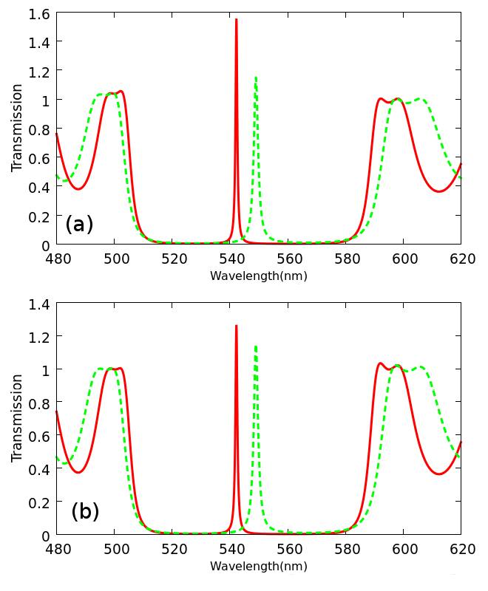
FIGURE 4 Computed comparison of gain in folded "defect" binary DFBs if (a) gain is in the low refractive index material, and (b) gain is in the high refractive index material. In each frame the solid line is for the fold on the low index material and the dashed line is for the fold on the high index material. The gain-index product is the same in both figures, indicating that, all else equal, the preferred combination for lowest threshold lasing for DFB's of this type is for the gain and fold to be both in the low index material.
Although we leave the details of the calculation to ref. [], it is straightforward to map out the electric field intensity as a function of location within the multilayer structure. Doing so, one finds that the defect structure yields a peak internal field energy density at the spatial location of the structure defect and at the wavelength of the spectral defect. This field energy density at the defect location (center fold) exceeds that found at the band edges of a simple stacked structure with the same number of layers, where the field energy density is greatest spectrally along the band edge, and is less localized spatially within the film. As the number of bilayers is increased, the peak field energy density is both further enhanced and more localized at defect states as compared to multilayers without defects. Figure 5 shows the results of numerical transfer matrix calculations of the electric field energy densities in a hypothetical folded 64 layer structures for an incident field from the left. In case (a), the center region is the lower refractive index material (here, n = 1.49) and in case (b) the center fold is on the higher index material (n=1.585). The regions of high energy density correspond to the antinodes referred to above and the energy is highest in the center of the fold, by a factor of two more than when the low refractive index material is in the center. Thus, it is expected (as in Fig. 4) that a defect binary DFB laser is optimized by having the gain medium in the lower refractive index material, with a doubled layer of low index material at the center of the stack.

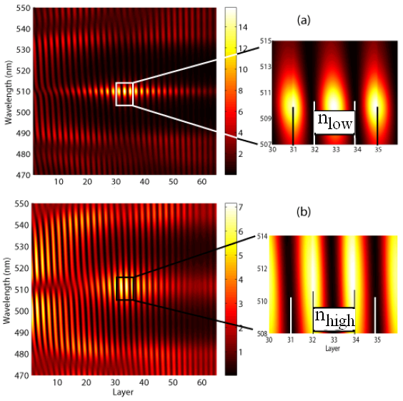
FIGURE 5 Electric field energy density contour plots for a 32-layer folded system showing the concentration of field energy at the center of the fold at the spectral location of the defect after folding onto (a) the low index material and (b) the high index material. Note that the field energy is also large at the band edges, as expected, but is not as localized nor as intense.
Gain Media
Having identified the basic structure and the optimal placement of the gain media for a DFB laser, we now briefly consider the nature of the gain media particular to fabricating polymer multilayer DFB lasers. The earliest organic laser gain media, first developed shortly after the laser’s invention, were fluorescent dyes,, first used in liquid solutions, mostly with toxic solvents, and with the commensurate hazardous waste problem. It was not long, however, that these dyes were first adapted for use in a solid polymer matrix,,, commonly poly-(methylmethacrylate) (PMMA). Not surprisingly, most multilayer DFB lasers have also taken advantage of the wide range of fluorescent dye molecules that are amenable to being dissolved into or chemically attached to the polymer host or dispersed with nanoparticle composites. These dyes are typically π-conjugated molecules with high quantum fluorescent yields, with some of the most common representative examples being the xanthenes (rhodamine [See Fig. 6] and fluorescein dyes), pyrromethenes, coumarins, and, more recently, organic photovoltaic (OPV) chromophores and semiconducting polymers, with optimal ranges for lasing from the blue to the near infrared.^{7,,,,,,}
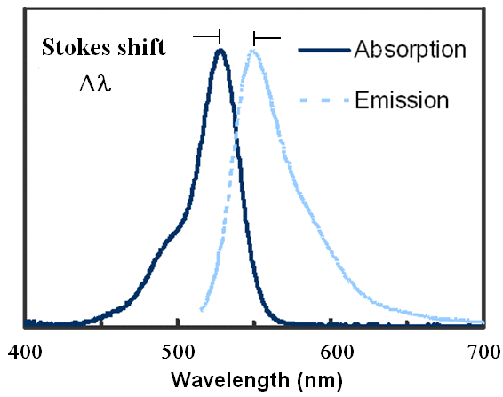
FIGURE 6 Normalized absorption and emission spectra of rhodamine 6G perchlorate dye in PMMA with approximate Stokes’ shift (Δλ) indicated.
To determine the appropriate dye concentration requires consideration of the interaction length in the multilayer. The actual thickness of dye material may be only on the order of ~10 microns (based on ~100 dye-doped layers at ~100 nm each), but the interaction length with the dye is much longer due to multilayer reflections. If the interaction length is sufficiently short that large dye concentrations are needed, then intermolecular interactions become very important and often lead to quenching, which is detrimental to the lasing efficiency and stability. For low intensities, as expected, the light intensity increases nearly exponentially with the interaction length in the material.
(6)
where is the stimulated emission cross section and is the population inversion density in the material, which together constitute the gain, .
In their recent review of solid-state organic lasers, Chénais and Forget provide a concise listing of the key features needed for the gain media in a polymer laser:²³
- Stability against moisture and oxygen, or encapsulation in an impervious barrier to the same.
- Photostability at the pump photon energies.
- Large quantum fluorescent yield and low-quenching in the solid matrix.
- Low re-absorption or scattering losses at the lasing wavelengths.
- Large stimulated emission cross-section to enable low thresholds.
- Low triplet-triplet absorption, low triplet state lifetimes, and a low intersystem crossing rate.
One of the important characteristics of many laser dyes is the breadth of their emission spectrum, which is a prerequisite to tunability, but can also raise the lasing threshold. Below, we show experimentally and theoretically how multilayer co-extruded polymer DFB lasers take advantage of a dye’s broad gain envelope through several different tuning modalities. The wide spectral range of the gain envelope also is responsible for the ability of these dyes to be used for generating short duration pulses.
The photoluminescent efficiency of light emission is described in terms of the quantum yield, the ratio of the number of photons emitted to the number of photons absorbed. Unfortunately, as the concentration of dye or active conjugated molecules increases, many otherwise promising gain materials tend to form aggregates, dimers, or excimers. Dyes that are strongly emissive in liquid solutions are easily quenched by these interactions in a solid matrix. To prevent this quenching, it may be preferable to attach the dyes as carefully spaced side groups to avoid aggregation. (This problem has also been considered extensively in the literature on organic light emitting diodes (OLEDs) with some success through the use of dendrimers to space out the chromophores from each other. )
Unfortunately, in solid matrices, dyes used to date have tended to suffer from low efficiency and fast photodegradation as compared to their liquid-dissolved forms. The process of photodegradation in systems of organic molecules has been studied for over half a century.^{75,,,} Optical devices that use organic dyes have a limited lifetime, as short as seconds to weeks, before the dye or entire device must be replaced.,, Although the lifetime of some organic dye-doped systems has been extended in certain cases, current understanding of photodegradation is still far from complete. The reasons for the lack of a complete theory are twofold: (1) the large assortment of dye configurations with differing properties and (2) the varying routes of photodegradation in each species of dye, such as chemical oxidation, formation of dimers, and basic thermal degradation. Examples of photodegradation mechanisms include phototautomerization, photoisomerization, photodenaturation, photoejection,,,, triplet-radical reactions, photodimerization, photodissociation, twisted intermolecular charge transfer (TICT), etc. Some of these processes such as photoisomerization are known to reversibly recover, while other processes like photoejection only show signs of self-healing when, under the right circumstances, both charge trapping and recombination occur. Within the current literature, however, most processes of photodegradation are irreversible with many molecular products of photodegradation still unknown.
Work on modification of laser dyes to make them more suitable for solid state applications is ongoing. For example, the dye commonly known as DCM (4-(dicyanomethylene)-2-methyl-6-(4-dimethylaminostyryl)-4H-pyran) has been modified by mixing it in a guest-host system with Alq3 (tris(8-hydroxyquinolinato)) instead of a completely passive matrix like PMMA. The combination not only helps to separate the DCM dye molecules, limiting concentration quenching, but it does so by simultaneously increasing the efficiency of the fluorescence process because the Alq3 molecule absorbs the pump light, and efficiently transfers that energy to the lower energy gap DCM molecules. This serves to absorb pump light more efficiently, and yields a larger Stokes shift between the absorption and emission wavelengths, reducing self-absorption. Note that in single species systems a small Stokes shift is desirable in order to reduce the amount of pump energy converted into destructive thermal energy in the system, but a large Stokes is desirable to limit re-absorption. The Alq3-DCM system thereby suggests a possible compromise between these two competing interests, yet issues relating to various routes to quenching in these systems persist.
Another approach is to use undoped, conjugated fluorescent semiconductor polymers,,, such as poly(phenylene vinyl-ene)s,,, or polyfluorenes,,, both of which are amenable to spin coating or ink-jet printing, but not necessarily solvent-free deposition. Polyfluorenes have been shown to be promising materials for blue laser emission pumped by microchip lasers,^{19,} and are one of several candidate polymer/copolymer blends being investigated for electroluminescence and possible electrical pumping. Polythiophenes have also been shown to be low threshold emitters in microcavity lasers.
As can be inferred from this brief review, much work is being done to improve gain media for all-polymer lasers. The range of laser dyes used in multilayer polymer DFB lasers to date is rather narrow. Particular examples are discussed below in context of reviewing laboratory systems to date. For further discussion of the advances in organic/polymeric laser materials generally, there have been several helpful reviews to which the reader may refer.^{23,75,84,} ,,,
Experimental Characterization
There are a wide variety of metrics used to characterize lasers and laser materials and a complete overview of parameters is not only beyond our scope, but is also made problematic by the varied approaches to pumping these lasers. In the discussion of experimental implementation below, we routinely quote the lasing threshold in terms of either pump irradiance or fluence (average pump energy divided by the pump beam area) at the onset of lasing. Also, we quote the lasing quantum slope efficiencies in terms of the steepest slope of the so-called “J-curve” of output power vs. pump power, as shown in Fig. 7(a). Quantum slope efficiency differs from the slope of the steep part of the curve shown only in that it is expressed in terms of the number of photons output per number of photons in the pump, i.e., the slope shown multiplied by the ratio of the pump wavelength to the lasing wavelength. The threshold, however, must be inferred by knowing the spot size of the pump laser at the pump power where the curve changes slope (here, at ~10μW pump power). Unfortunately, neither of these metrics can be considered to be completely independent of the pump duration, repetition rate, and other parameters, and comparisons across groups are not always reliable indicators of the relative performance between systems. Also, the presence of a threshold for increased emission efficiency is not sufficient evidence in the absence of the other conditions for lasing. At threshold, one finds substantial spectral narrowing of the output mode expected for the DBR structure and evidence of coherence in the output beam.¹⁰⁴ Figure 7(b) shows the output beam from a co-extruded polymer DFB laser (vide infra). The short cavity length implies a cone of light, but there are evident diffraction rings in the output structure and a narrow spectral width, both further indicators of lasing. Other metrics to consider are the coherence length, mode structure, beam divergence, peak power, damage threshold, and useful life.⁷
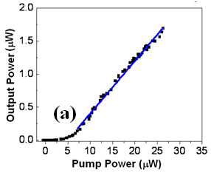

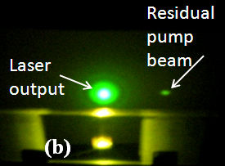
FIGURE 7 (a) Average output power as a function of pump power for the DFB laser in Ref. []. Here the slope efficiency is 8% and the lasing threshold is found to be 100μJ/cm². (b) Sample output beam showing conical output and diffraction rings due to coherence. (Reproduced with permission from The Royal Society of Chemistry.)
Fabrication: Putting It All Together
As inferred by Fig. 2, the number of layers needed for the DFB/mirror system is a function of the refractive index difference between the layered materials as well as the amount of gain in the layers. Large refractive index contrast can be found in hybrid organic/inorganic systems having low numbers of layers and wide band gaps, but these systems are not amenable to easy processing. Large and small refractive index systems (n>1.7, n<1.37) typically require more complex manufacturing methods such as vacuum deposition, liquid phase epitaxy, etc. and are beyond the scope of this review. Thus, to achieve the large reflectivities needed for a DFB laser structure with all-polymer multilayer systems typically requires on the order of a hundred layers or more due to the relatively small refractive index differences available.
Once a suitable dye-host polymer system is found, another issue is the mechanical, chemical, and thermal compatibility with the other polymer making up the DFB and the layering process. Similarity in structure between polymers can lead to large interfacial regions, which can be particularly problematic for maintaining the interface between gain layers and chromophore-free regions. The two techniques used to date for forced assembly are spin-coating, which is a well-established, but more tedious process for producing large numbers of layers, and melt-processed co-extrusion.
Spin-coating
An assembly technique that requires constructing the multilayer one layer at a time may be primarily of research interest due to the time and number of steps required to assemble enough layers. Nonetheless, some early work on the construction of distributed Bragg multilayers by spin-coating and other layer-by-layer technique merits discussion. Recent work suggests ways to improve the speed of the process, but which have not yet been applied to a DFB system.
The general process of spin coating of polymers from dilute solution is well known, having been employed in the semiconductor industry for decades in the use of photoresists. Because the DFB laser process usually employs ultrathin films of less than 200 nm, however, the control of the layer thickness and uniformity can seem more of an art, requiring repeated trial and characterization through interferometric or profilometric means, especially when thickness control at the nanometer level is desired. Broadly, the film thickness has been seen experimentally and roughly modeled to scale as
(7)
where is the initial solution viscosity, and is the spin rate, with thicker layers requiring slower speeds at the risk of loss of uniformity. This prediction depends, of course, upon many other material parameters such as the mass fraction/polymer concentration in the solution and characteristics of the solvent gas phase above the sample, e.g., the diffusivity of the solvent in the gas phase. Generally, less volatile solvents lead to more uniform films due to slower solvent evaporation. Further, high viscosities, which can arise from high concentration of polymer (more than a few percent), lead to less uniform films. A detailed consideration of the parameters involved in relating the spinning parameters to the resulting film thickness can be found in refs. [] and [], which consider initial solvent volatility/evaporation rate during the coating and spinning process, as well as non-Newtonian fluid effects.
The use of spin coating to produce a multilayer polymer system dates back to the 1970’s.³ The quality of spin cast films is typically limited by the number of layers spun which is limited by the tendency for the dissolution or disruption of previous layers as each new layer is added as well as by the time and effort required for each layer. Spin casting of multilayers requires the use of mutually exclusive solvents for the alternating polymer layers. Bailey and Sharp spun 50 alternating layers of polystyrene (PS) and poly(vinylpyrrolidone) (PVP) producing films with 55% reflectance in the visible (a higher order reflection band). Although this reflectance is too low for use as a laser mirror or DFB system, they found that automation of the spin-coat process (primarily rotor speed) enabled them to produce chirped structures useful for customizing the reflection band.²⁸ Interfacial regions were estimated to be around 10-20 nm for the spun layers.
Multiple groups have successfully fabricated flexible multilayer DFB lasers by spin coating alternate layers of cellulose acetate (CA, n~1.475_{NaD}) (dissolved in alcohol) and poly-N-vinylcarbazole (PVK, n~1.683_{NaD}) (dissolved in chlorobenzene)., In ref. [129], the CA layers were doped with 0.5 wt% R6G, which exhibited band edge lasing at 580 nm in a simple alternating structure of 19 layers. When pumped by 5 ns frequency doubled Nd:YAG pulses at 532 nm and 1Hz repetition rate, the threshold was estimated to be 17 mJ/cm². In ref. [130], both the CA and PVK polymers were doped with 2 wt.% pyrromethene-567. Single mode lasing was achieved at a band defect at 568 nm, created by inserting a single wavelength spacer near the center of the DFB structure. In that case, the total of 68 layers was made in three parts, with a center 400 nm doped CA gain layer, between 31 and 36 dye-doped CA/PVK reflector layers. Compared to a similar DBR system with only a center doped layer, the threshold at 260 nJ/pulse (or 300μJ/cm² pulse energy density) was substantially lower due to the doping of the reflector layers. Similarly, the laser was pumped with the frequency doubled output of a Nd:YAG laser at 532nm at 7ns pulse duration, with a 10 Hz repetition rate.
An alternative to repetitive spin coating, though still somewhat tedious, is spin coating of large removable single layers that can be then cut and stacked to form the multilayer structure. This is the technique used by Komikado and co-workers who built an early all-polymer DFB laser in 2006 by spinning CA and PVK at a thickness corresponding to three-quarter and one-quarter wavelength optical thickness, respectively, and stacking them in a 39-layer stack. The CA layers were doped with R6G at 0.5 wt%, which also necessitated that thicker layers be used to ensure sufficient absorption of the pump laser. The resulting laser output was, as expected, at the short wavelength band edge of 590 nm when pumped by a doubled Nd:YAG laser at 10 ns pulse duration. The lasing threshold was ~50 μJ/pulse.
The versatility of the doped PVK/CA system has also been shown in a hybrid structure comprised of a ten pairs of TiO₂/SiO₂ layers forming a DBR mirror on which a 1-μm thick coumarin 540A doped PVK center layer was spun followed by up to 25 pairs of CA/doped-PVK bilayers. This DBR/defect/DFB hybrid inorganic/organic multilayer laser was then pumped by a 4-ns pulsed InGaN-based blue laser diode at 441 nm and a 100 Hz repetition rate. The lasing threshold at 563 nm was found to be only 370 mJ/cm², much lower than the same group’s similar effort with pyrromethene 567 doped and pumped at 532 nm by a doubled Nd:YAG laser.
Also of note is the work by Joon et al.,⁶⁷ in which spun alternating layers of PMMA (99 nm each, n~1.49) doped at 0.5% with 4-(dicyanomethylene)-2-methyl-6-(4-dimethylaminostyryl)-4H-pyran (called DCM, Exciton) and titania (TiO₂) nanoparticles (88 nm, n=1.78 at 500 nm)) formed a 61-layer structure with a 1.54 μm dye-doped PMMA gain layer at its center. The assembled multilayer lased at a 582 nm defect in the reflection band (coinciding with the peak emission wavelength of the DCM doped PMMA) when pumped by a frequency doubled Nd:YAG with 5 ns pulses at 50Hz repetition rate. The lasing threshold was found to be ~17mJ/cm² (12 μJ/pulse over a 300μm pulse diameter).
Multilayer Co-Extrusion
Multilayer co-extrusion of polymers has been used to make multilayer interference gratings for over 40 years, since first developed at Dow Chemical Company, and it has been used commercially in the production of low-cost, large-area reflective films. A major breakthrough in the creation of low-cost multilayer DFB lasers appeared, however, when new developments in customizing the multilayer co-extrusion enabled increased design flexibility in the multilayer process., In this process, two thermoplastic polymers of differing refractive index are melt-pumped through a series of layer multipliers, splitting and recombining the melt flow with minimal path length differences along the extrusion path. The extrusion temperature is chosen to match the rheologies of the polymers so that they flow more uniformly through the system. (A plug flow rheometer or melt flow indexer is used to predict the melt viscosity as a function of temperature.) The operation of this co-extrusion process to enable roll-to-roll processing of multilayer DFB lasers and other devices can be found in refs. [,].
As can be seen in Fig. 8(a), at each layer multiplier the horizontal stack is split vertically into two melt streams and then recombined by forcing half the melt to flow above the other half, doubling the number of layers at each stage. By repeated dividing, spreading, and stacking, the number of layers grows as 2^{n+1}, where n is the number of doubling dies used. After the desired number of layers has been reached, which can be in the thousands, a removable surface “skin” layer, such as polyethylene (PE), is typically extruded to protect the multilayers, which are then spread in an exit die to form large area films, as seen in Fig. 8(b). Note that the skin layers are thick compared to the multilayers and occupy 50%-90% of the final film volume, enabling easier handing of the films. After the melt has been spread into the desired dimension and corresponding layer thickness, a chilled take-up roll is used to quench the melt and smooth the surface finish. The final multilayer film, after removable of the skin layer, is typically 3 to 12 microns thick overall.
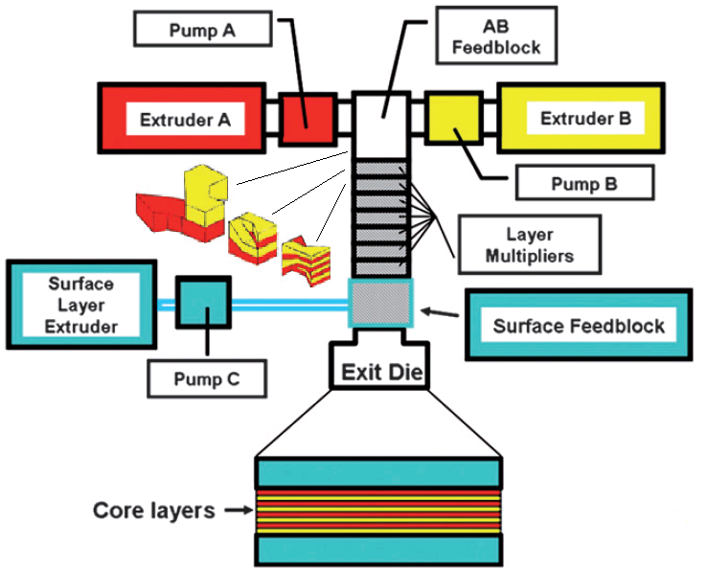
(a)
FIGURE 8. (a) Schematic of the co-extrusion process whereby polymers from extruders A and B are layered and then protected by the surface layer from pump C. (Reproduced from [122], with permission from The Royal Society of Chemistry.) (b) Photo of rhodamine 6G dye-infused multilayer exiting the chill roll.
(b)
The roll-to-roll technique enables the solvent-free fabrication of multilayers for which the band gap shape and position can be readily modified to the desired design. To date, over a hundred different polymers have been successfully co-extruded by this method, with good optical quality films obtained over a wide range of polymers, including polypropylene(PP), polyethylene(PE), polystyrene(PS), polycarbonate(PC), poly(vinylidene fluoride)(PVDF), PMMA, and related blends, some of which are described further below.¹³⁸
Experimental Characterization of Multilayers
For any multilayer DFB laser fabrication method, it is useful to consider the uniformity of the layers across the area of the film and the layer-by-layer thickness uniformity to the desired periodicity. Unfortunately, standard ellipsometry techniques used to measure thin film thicknesses are not capable of investigating more than a few layers into the multilayer stack. Furthermore, it is a very complex inverse problem to use the features of the transmission or other spectra to infer the actual layer thicknesses, particularly in the presence of absorptive and scattering losses. The most direct approach, then, is to cleave across the multilayer polymer stack, which is most effectively done with a cryogenic microtome, and then scan across the cleaved end using atomic force (AFM) or scanning electron (SEM) microscopies. Figure 9(a) shows the results of one such AFM scan across the system described in Ref. [122]. In this case the layers were found to be 95±25 nm thick, but, more significantly, there is good agreement between the transmission spectra predicted by the transfer matrix method using the measured layer thicknesses and the actual transmission spectrum of the film (Fig. 9(b)). As expected when using even just one fewer layer multiplier, the layer thickness variation is reduced for a 64-layer film to about 18%.
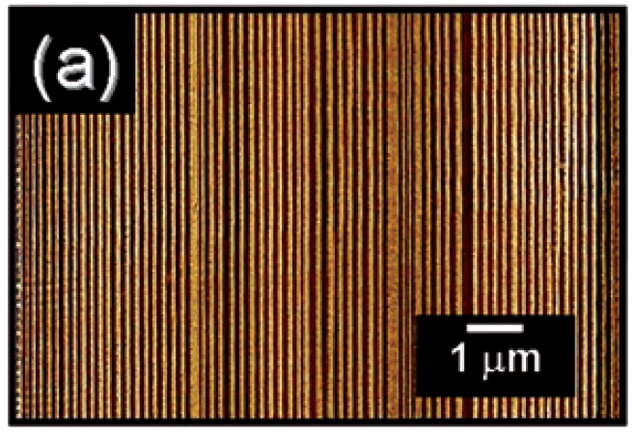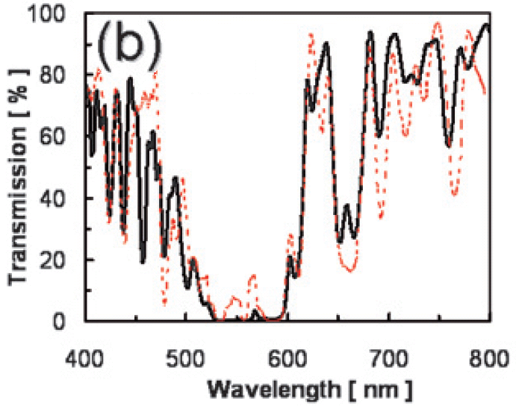FIGURE 9 (a) AFM image of the cross-section of a multilayer film showing layer-by-layer thickness variations across 128 layers, and (b) transfer matrix simulation of the transmission spectrum for the 128-layer film (dashed red line) compared to the experimental transmission spectrum (solid black line). (Reproduced from [122], with permission from [The Royal Society of Chemistry].)
Progress with Co-Extruded Multilayer DFB Lasers
The first use of multilayer co-extrusion of micro-resonator laser cavities was not as a DFB laser, but as distributed Bragg reflectors (DBRs) laminated onto a dye-doped gain layer two or more orders of magnitude thicker than the individual Bragg layers. The best performing of these systems showed a threshold of 35 μJ/cm² at 50% optical efficiency using a 53 μm pyrromethene gain layer in a PVDF/PMMA blend at 1.9 wt% of dye. This DBR approach has the advantage of versatility in that the center gain layer can be almost any gain media in any compatible host. The disadvantage is, of course, the extra processing required to combine the mirrors and the gain medium. This system is noteworthy also for the insights it provides for our understanding of the effective length of the resonator cavity with DBR mirrors in relation to the thickness of the gain layer and the presence of nonuniformity in the mirror layers. The delocalization of light propagating in modes within the bandgap and localization of light in modes outside the band gap was explored in detail in the context of Anderson localization in ref. [].
Soon after the first successful melt-processed DBR laser, the same research group blended laser dyes directly into one of the two extruded polymers, producing a true DFB multilayer structure.¹²² These first co-extruded roll-to-roll processed DFB lasers were fabricated from dye-doped poly(styrene-co-acrylonitrile) with 25 wt% acrylonitrile (SAN25) alternated with layers of a fluorelastomer terpolymer of vinylidene fluoride, hexafluoroproplyene tetrafluoroethylene (Dyneon THV 220G) (THV), and skin layers of low density poly-ethylene (Dow LDPE 6201). The refractive indices of the two constituent polymers at 633nm were found to be 1.57 and 1.37, respectively, producing highly reflective films from 64 and 128 layer stacks. The laser dyes used were commercial R6G and a newly-synthesized 1,4-bis-(α-cyano-4-methoxystyryl)-2,5-dimethoxy-benzene (C1RG, absorption max at 434 nm, fluorescence peak at 515 nm)⁷⁹ which were then pumped by 7 ns, 10 Hz, Nd:YAG based optical parametric oscillator at 532 nm and 489 nm, respectively. Both dyes were insoluble in the lower index THV polymer and so were solution blended in chloroform into SAN25 and then further diluted with neat SAN25 into a nominal 1 wt% dye concentration. The THV/SAN25 pairing was chosen because THV acted, in this case, as a barrier layer for the dye, sequestering the dye in the SAN25 during melt processing. Though the melt processing temperatures are not so high as to destroy the laser dyes, the dyes tend to diffuse through many polymers, even to the point of leaving the multilayer system during extrusion. The effectiveness of the THV as a barrier layer appears to depend upon the polarity of the dye. It provided an effective barrier for R6G, but some diffusion was still evident with the C1RG dye.
Although 128 layer films exhibited the desired reflectivities in the bandgap region, it was found that stacking films with 64 layers improved the uniformity and performance of the system. The highest slope efficiency of more than 10% was seen in a stack of five 64-layer films, which showed a lasing threshold of 100μJ/cm². As expected for the complicated band structure that resulted from non-uniform layer thicknesses, lasing occurred at a defect state within the bandgap, rather than at the long wavelength bandedge. As can be seen in Fig. 10, spectra of the multilayer films depend on the relationship between the reflection band, cavity interference, dye absorption and re-absorption. The reflection band not only shifts to the blue with increasing incidence angle (Fig. 10(b)), but the shape of the band changes as well due to the relative contribution of dye absorption across the band. As expected, the lowest thresholds appeared when the pump angle of incidence was at a transmission maximum, entirely outside of the reflection band.

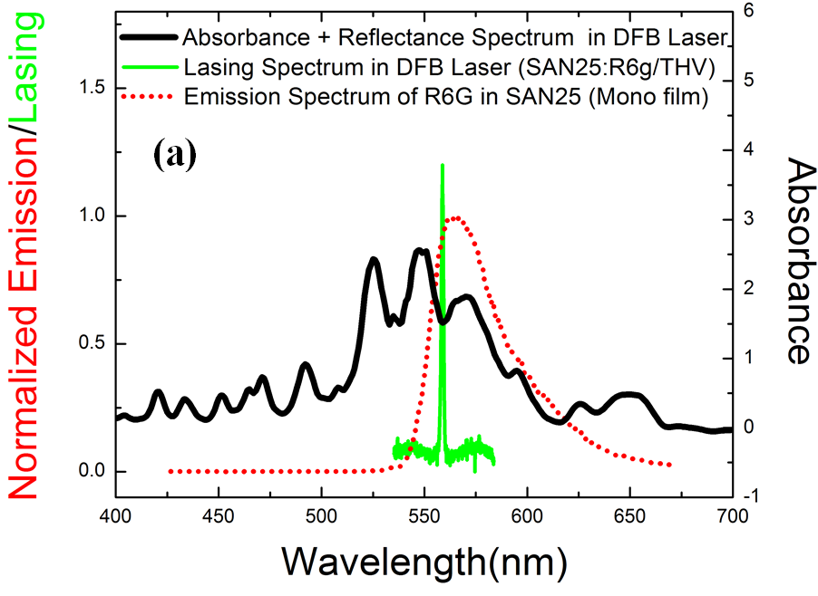
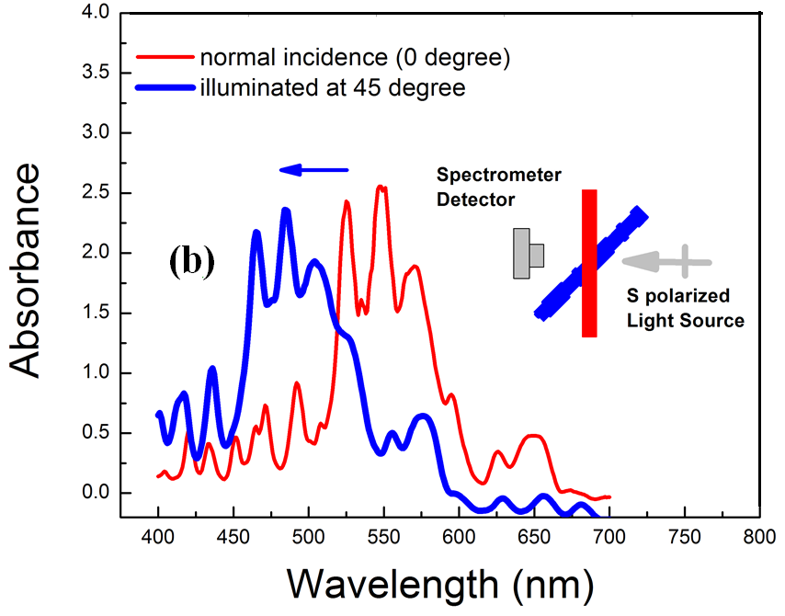
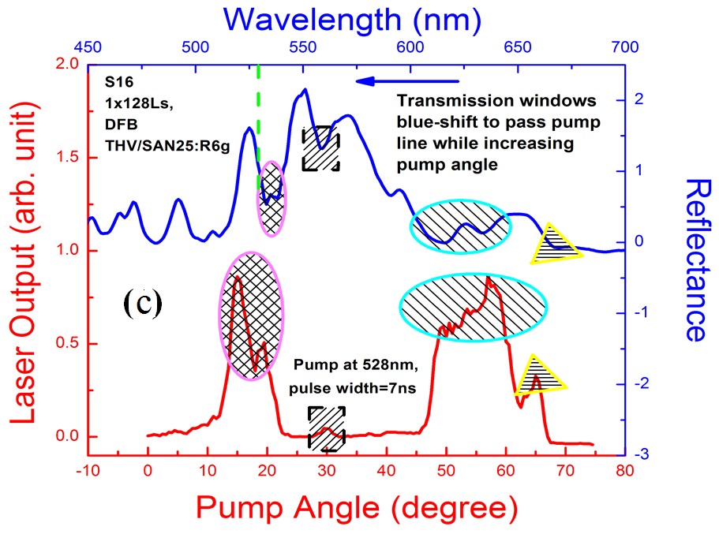
FIGURE 10. (a) Normalized emission (dotted red) from a monolithic SAN25:R6G film, is plotted together with lasing (green) and the absorbance/reflectance (black) spectrum (log scale) of a 128-layer DFB laser. (b) Blue-shifted absorbance/reflectance spectrum at oblique incidence. (c) Top blue curve is the reflection band from the device (reconstructed), dashed green vertical line is the 528nm pump, and bottom red curve is the pump-angle dependent lasing output with steady incident power. Shaped areas mark the transmission windows in the dressed reflectance spectrum and their corresponding lasing output in the pump-angle resolved lasing spectrum. Dressed reflectance was obtained from a transmission measurement, including contributions from both reflection band from the DFB laser and absorption from the doped dye and materials.(Reproduced from [ with permission from Old City Publishing, Inc. .)
Tunability in Multilayer Polymer DFBs
One of the historic strengths of dye lasers is that they can be widely tuned by using the broad emission spectra of the gain media due to the tight dependence of the lasing wavelength on the optical structure of the resonator cavity. For conventional liquid and Fabry-Perot cavity dye lasers, tuning is usually accomplished by the use of a separate rotating reflective diffraction grating element in the resonator., For dye-based multilayer DFB lasers, tunability is internal to the multilayer resonator itself. In some cases, this leads to even broader tunability than seen with the same dyes in conventional Fabry-Perot resonators. For example, with R6G dye, the typical liquid solution dye laser is tunable over a 40-50 nm range, but with the same dye in multilayer polymer films with different preferred defect lasing modes, we have observed lasing over a range from 560 nm to 650nm.
Three independent tuning mechanisms have been demonstrated with co-extruded polymer DFB lasers. These are (i) structure design tuning through the use of a terraced defect center layer,⁷⁰ (ii) mechanical tuning through the use of elastomeric polymers, and (iii) temperature tuning using the thermal expansion characteristics of the constituent polymers. While none of these modalities, taken singly, is previously unrecognized, we believe their simultaneous employment in multilayer polymer DFB structures is unique and likely advantageous for applications.
As a point of comparison, note that corrugated grating DFB lasers have also been tuned by refractive index changes,, stretching,, thermo-refractive effects, and defect layer thickness changes., Grating-based DFB lasers in waveguide structures also have been shown to be tunable by varying the thickness of the film over the grating, independently from the grating spacing. Discrete spectral tuning and switching using defects has also been demonstrated in cholesteric liquid crystal DFB systems.,,
Structure Tuning
As previously described, one of the possible ways to improve upon a simple multilayer DFB structure is to insert a phase slip defect, e. g., a layer towards the middle of the stack that breaks the periodicity. This change from the otherwise perfect alternating quarter-wave thickness of the layers creates a corresponding spectral defect in the reflection band at which the group velocity delay is large. Lasing preferentially occurs at the spectral defect location in the reflection band and, by modulating the thickness of defect layer, one can continuously tune the laser output wavelength.
Even in the presence of random variations in the layer thickness around the idea quarter-wave stack, the use of more prominent phase-slip defects can be used to improve and control lasing. Use of deliberate phase-slip defects to control lasing was demonstrated using co-extruded multilayer R6G-doped DFB laser films.⁷² Lacking a substrate, these melt-pressed films (comprised of alternating SAN25 and THV layers, as described above) are particularly amenable to simple post-process folding to create phase-slip half-wavelength defects. In this case, folding vs. stacking of the multilayers led to a 3- to 6-times increase in lasing efficiency and a lower lasing threshold. See Fig. 11.

FIGURE 11. The conversion efficiency of a defect DFB film created by folding a 64-layer THV/SAN25 film (red squares) and a simple DFB laser created by stacking two 64-layer DFB films so that there is no defect center fold (black circles), in both cases creating 128-layer DFB lasers.
Further, by using a weak solvent to terrace the layer that would become the center, thickness defects of various thicknesses were fabricated, as shown in the right most schematic of Fig. 1(c). This enabled tuning of the laser in discrete steps. By simply shifting the lasing spot on the film a matter of millimeters, and taking advantage of the broad fluorescence of R6G dye, the wavelength was tuned across much of the reflection band. See Fig. 11.
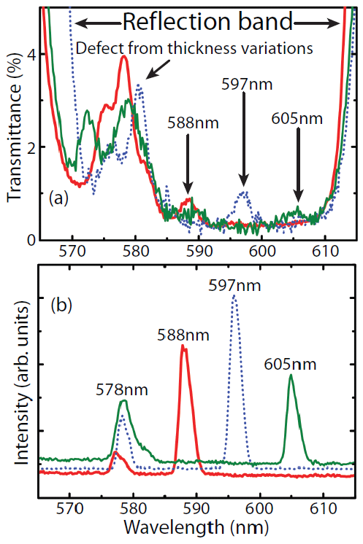
FIGURE 12. (a) Transmission curve of 128-layer folded terraced-defect laser film. (b) Laser spectra of the 128-layer folded terraced-defect laser film at three different center thicknesses. (Reproduced from [70], with permission from The Optical Society of America.
As the center layer is thinned, the spectral defect moves to shorter wavelengths until it disappears into the band edge when the thickness corresponds to the standard quarter-wavelength optical thickness. When the center layer is thinned still further, a spectral defect in the bandgap will reappear at the long wavelength reflection band edge and again shift to shorter wavelengths. Of course, if the layer is thinned to vanishing, the defect state again appears as a center fold defect, but this time due to a doubling of the thickness of the refractive index constituent now at the center.
Mechanical Tuning
The spectral location of the bandgap can be made mechanically tunable by fabricating the multilayer laser film using elastomeric polymers. While this feature has not yet been realized fully in a multilayer DFB structure, it has been demonstrated in distributed Bragg reflector filters, first by spin coating,³ and, more recently, by co-extrusion of elastomers.¹⁵³ In the latter case, 128 alternating layers of THV, and ethylene-octene (EO, n≈1.48) were co-extruded with a R6G dye-doped Lotader elastomeric skin layer, which acts as the thick active central gain medium when the films are folded to create the microcavity Bragg laser. The Lotader skin layer is a blend of ethylene terpolymer with 40% by weight acrylic ester and glycidyl methacrylate [Arkema, www.lotader.com]. The average layer thickness was approximately 110nm and the center layer thickness was approximately 30μm after folding.
A pseudo-affine model relates the shift λ/λ₀ of the reflection band center wavelength, λ₀, as a function of the lateral linear strain, Δl/l₀
(8)
where are the initial and the final indices of refraction in the direction of stretching and perpendicular to the direction of stretching, respectively. For small strains (<0.2), the induced birefringence was essentially negligible , yet stretching the laser film yielded nearly continuous wavelength tuning from red to green (from ~625 nm to ~570 nm), as seen in Fig. 13.
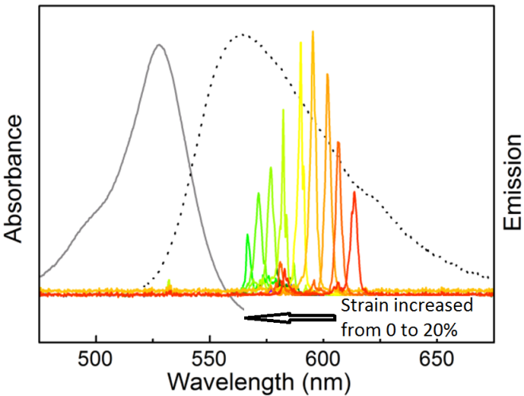

FIGURE 13. The series of sharp curves are the emission spectra at different stretching ratios for the DBR laser. The solid gray curve to the right is the absorption spectrum and the dotted line is the fluorescence spectrum of the R6G dye in the Lotador matrix. (Reproduced from [151], with permission from Old City Publishing, Inc.)
Temperature Tuning
Whether laser output variability with temperature is desirable depends upon your point of view. Many applications require a stable output frequency and drifts due to temperature must be carefully suppressed. Other applications, however, benefit greatly from the ability to tune the wavelength simply by changing the temperature. Fortunately, due to the wide range of polymer choices, it is possible to design a multilayer polymer DFB system for either type of application. The key, however, is to consider not only the thermo-mechanical and optical properties of the polymer constituents, but also how those constituents will interact when constricted in the multilayer.
Most, but not all, polymers expand with temperature. Thermal expansion leads to two competing effects on the band structure: the thickness of a layer is expected to increase, but the index of refraction drops. Because the optical pathlength is the product of the thickness and refractive index, these two effects partially offset one another, but do not, in general, cancel. The situation in a multilayer is more complicated, however, because the two (or more) constituent materials may expand at different rates. This expansion is particularly problematic in a multilayer because the layered materials are tightly fused together (in many cases involving interdiffusion regions of tens of nanometers or more) and are thus constrained to maintain the same expansion rates along the contact surface. (It is assumed that they do not delaminate.) In a bilayer system, the difference in thermal expansivities leads to the bending of one material over the other, as in the familiar bimetallic strip, but this is not possible in a system of tens or even hundreds of layers. If the two polymers are not matched in their expansion rates, the rate will be dominated by which of the materials is more rigid (typically, but not necessarily, the polymer with the smaller thermal expansivity). In compliance with Poisson’s ratio relating the bulk expansion rate to the linear expansion rate, either the lower expansivity layers will not thicken as much as expected perpendicular to the film plane because they are forced to expand more in the directions along the interfacial plane or the higher expansivity polymer layers will thicken more than otherwise expected as they are unable to expand along the interfacial plane. Measuring, let alone predicting, the response given a specified pairing of polymers in a multilayer is an ongoing area of research. To measure the changes in thickness and refractive index directly requires a level of precision that is easily obtained by interferometry.
Fortunately, observation of changes with temperature in the optical band structure and laser output, together with the multilayer modeling methods described above, greatly aid in our understanding of these effects.¹⁵⁴ We have explored the thermo-optic spectra of both polymer DRB and DFB laser structures. The DFB systems were comprised of alternating layers THV and SAN25 as previously described, which were folded alternately onto the THV or SAN25 layer. In this system, modeling of the measured response indicates that the more rigid SAN25 polymer constrains the in-plane expansion of the THV polymer, which responds in the multilayer by increasing in thickness by nearly a factor of three more than would be expected from isotropic properties.¹⁵⁴ As the temperature of the system increased, the reflection band not only shifted to longer wavelengths, it also expanded, with the long wavelength band edge shifting more than the short wavelength band edge. Due to layer thickness variations throughout the stack and the field energy dependence of the center layer defect, lasing appeared near opposite band edges depending upon polymer in the center defect layer. The lasing at opposite band edges leads to different thermo-spectral coefficients for the two different folded DFB lasers, as can be seen in Fig. 14.
Note that in each case, the broad emission spectrum of the dye also changes slightly with temperature, but this change has little effect on the lasing wavelength which is otherwise dominated by the dispersion of the DFB resonator cavity and the location of the dye layers.
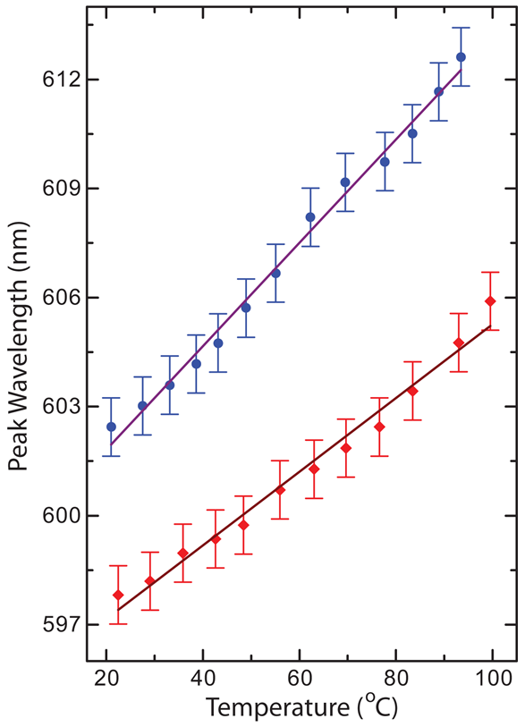
Figure 14. The peak lasing wavelength as a function of temperature for defect DFB lasers folded on (blue circles) THV and (red squares) SAN25. As predicted by modeling, lasing in the top trace follows the long wavelength (low energy) band edge which exhibits greater temperature dependence than the lasing shown in the bottom trace which follows the short wavelength (high energy) band edge. The solid lines are linear fits to the experimental data. (Reproduced from [154], with permission from The Optical Society of America.)
To further explore the thermal effects of combining different polymers, we also studied two very different DBR systems, each with the same R6G gain layer. These results, though not involving a DFB system, are important because they are directly relevant to the design of a DFB system for a desired thermal response. Briefly, when the DBR mirrors were made of alternating layers of THV and Ethylene Octene (EO) polymers, the mismatch in thermal expansivity between EO and THV led to a large thermo-spectral response on the order of a nanometer per ~3ºC temperature increase. However, when the same gain layer was placed between DBR mirrors comprised of the polymers PMMA and PS, whose thermo-elastic properties were well matched, the system showed an order of magnitude less sensitivity to temperature. (See Fig. 15.) Thus, the composition of a multilayer system has a significant impact on the temperature response. These spectral changes also provide new insights into how the two polymers respond to being constrained together in the multilayered system. The study of post-extrusion constraints on multilayer systems is a rich area for further research, with possible device/sensor applications beyond lasers.
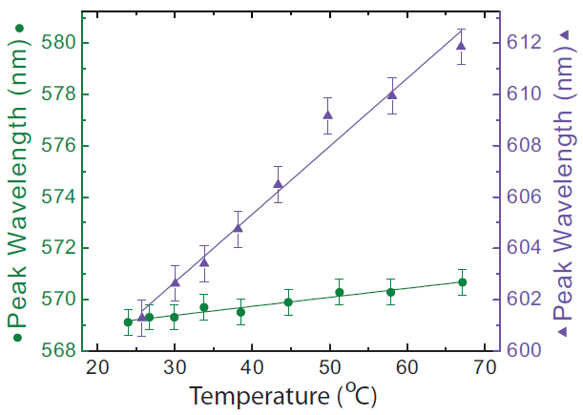FIGURE 15. The peak lasing wavelength as a function of temperature for two DBR lasers made by folding the same R6G-doped Lotador cavity between 128-layer films of alternating THV/EO (triangles)and PS/PMMA (circles). The lines in both graphs are the linear fits to the experimental data. (Reproduced from [154], with permission from The Optical Society of America.)
PROSPECTS AND PROMISES
We have demonstrated that co-extruded multilayer polymers promise to be an easily mass-produced laser material offering advantages over corrugated grating-based DFB lasers due to their large area available for lasing, flexibility and ease of manipulation, and wide range of mechanisms available for tuning the output. Further work will be needed to achieve some of the performance characteristics that have been demonstrated in long-studied corrugated grating-based DFB lasers such as extended operation, and the use of microchip lasers as pump sources.¹⁵⁹ Further improvements in tunability and extended operation are possible with improved dyes and/or quantum dot emissive sources.,
In order to achieve lasing with low cost and/or continuous wave pump sources, lasing thresholds will need to be lowered by nearly an order of magnitude from the earliest coextruded systems. Improved layer uniformity, increased refractive index differences, lower parasitic absorptive and scattering losses, better dyes and other emissive species, and use of optimized defect structures suggest that performance parity with other DFB lasers is within reach.
Indeed the use of inexpensive optical pump sources, such as laser diodes, diode-pumped solid state lasers (DSSLs) or even light emitting diodes may be the method for achieving the elusive “holy grail” of electrically pumped widely tunable polymer lasers. While, obviously a different approach than direct electrical pumping of organic semiconductor lasers, ^{114,,} this could possibly fill a similar niche.
Low cost, small, tunable laser sources are applicable to specialty spectroscopic systems, such as chemical sensors, and even DNA sequence sensors. Dye lasers continue to be widely used in medical applications, and, for example, low-cost tunable polymer DFB lasing surfaces could be used even as disposable laser sources for dermatological applications applying the multilayer laser films directly to the skin. In light of the technical developments outlined in this review and the great portent of manifold economical applications, further sustained development efforts towards this versatile class of laser materials should continue to reap widespread benefits.

ACKNOWLEDGEMENTS
The authors are grateful to the National Science Foundation for ﬁnancial support from the Science and Technology Center for Layered Polymeric Systems under grant number No. DMR 0423914 and to the State of Ohio, Department of Development, State of Ohio, Chancellor of the Board of Regents and Third Frontier Commission, which provided funding in support of the Research Cluster on Surfaces in Advanced Materials. The authors also thank Dr. Nathan Dawson and Michael Baker for research assistance.

REFERENCES AND NOTES
[References currently appear below the author photos and other ancillaries but will be directly inserted here instead of using Word’s “Insert Endnote” References feature when preparing the final version for production review. ]


James H. Andrews received his PhD in Physics from Case Western Reserve University (Case) (1995) while researching organic nonlinear optical materials. Dr. Andrews joined the faculty at Youngstown State University (YSU) in 1996 where he is currently a professor. His research is primarily on coherent optical processes, particularly in structured materials.


Michael Crescimanno received his Ph.D. in Physics from University of California, Berkeley (1991) for various studies in low dimensional quantum field theories, gravitation and string theory. His most recent work is in the areas of quantum optics, optics and mathematical physics. Dr. Crescimanno joined the physics faculty at Youngstown State University in 2000 where he is currently a professor.


Kenneth D. Singer received his Ph.D. in Physics from the University of Pennsylvania (1981) for studies of nonlinear optics in organic materials. Following eight years as a member of the technical staff at Bell Laboratories, he joined the faculty at Case Western in 1990. His research centers on optical and electronic properties of organic materials. Dr. Singer is currently the Ambrose Swasey Professor of Physics at Case Western Reserve University.


Eric Baer received his degree of Doctor of Engineering from Johns Hopkins University in 1957 while researching heat transfer in condensation. His most recent work is in the areas of micro- and nano-layered film systems and applying lessons from nature to the development of polymeric systems. Professor Baer joined the faculty of Case Western Reserve University in 1962. He is currently The Distinguished University Professor and Director of the NSF Science and Technology Center on Layered Polymeric Systems.

GRAPHICAL ABSTRACT
AUTHOR NAMES James H. Andrews, Michael Crescimanno, Kenneth D. Singer, and Eric Baer
TITLE Melt-Processed Polymer Multilayer Distributed Feedback Lasers: Progress and Prospects
TEXT ((up to 75 words, not the same as the abstract text, present tense, no personal pronouns, written for a non-specialist, see recent issue for examples)) Multilayer polymer distributed feedback lasers offer advantages due to their large areas available for lasing, flexibility and ease of manipulation. These multilayer laser films are easily mass-produced through a melt-processed co-extrusion technique. Their versatility is especially evident from the wide range of mechanisms available for tuning the laser output wavelength, including temperature tuning, mechanical stretching using elastomeric polymers, and tuning through the introduction of folded-in structure defects.

GRAPHICAL ABSTRACT FIGURE 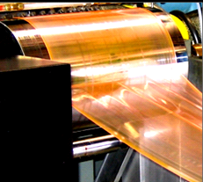

R. R. Søndergaard, M. Hösel, F. C. Krebs, J. Polym. Sci., Part B: Polym. Phys. 2012, 51, 16-34.
A. C. Edrington, A. M. Urbas, P. DeRege,, C. X. Chen,, T. M. Swager, N. Hadjichristidis, M. Xenidou, L. J. Fetters, J. D. Joannopoulos, Y. Fink, E. L. Thomas, Adv. Mater. 2001, 13, 421-425.
M. Kimura, K. Okahara, T. Miyamoto, J. Appl. Phys. 1979, 50, 1222-1225.
J. Kunzelman, B. R. Crenshaw, C. Weder, J. Mater. Chem. 2007, 17, 2989-2991.
J. W. Kang, E. Kim, J. J. Kim, Opt. Mater. 2002, 21, 543-548.
C Ryan, CW Christenson, B Valle, A Saini, J Lott, J Johnson, D Schiraldi, C Weder, E Baer, KD Singer, J Shan, Adv. Mater., 2012, 24, 5222-5226.
S. Chenais, S. Forget, Organic Solid State Lasers; Springer Series in Optical Science; Springer-Verlag: Berlin, 2013; Vol. 175.
H. Kogelnik, C.V. Shank, Appl. Phys. Lett. 1971, 18, 152-154.
C. V. Shank, J. E. Bjorkholm, H. Kogelnik, Appl. Phys. Lett. 1971, 18, 395-396.
C. Kallinger, M. Hilmer, A. Haugeneder, M. Perner, W. Spirkl, U. Lemmer, J. Feldmann, U. Scherf, K. Mullen, A. Gombert, V. Wittwer, Adv. Mat. 1998, 10, 920-923.
T. Spehr, A. Siebert, T. Fuhrmann-Lieker, J. Salbeck, T. Rabe, T Riedl, H. Johannes, W. Kowalsky, J. Wang, T. Weimann, P. Hinze, Appl. Phys. Lett. 2005, 87, 161103.
S. Y. Chou, P.R. Krauss, P. J. Renstrom, Appl. Phys. Lett. 1995, 67, 3114-3116.
M. Lu, B. T. Cunningham, S.-J. Park, J. G. Eden, Opt. Comm. 2008, 281, 3159-3162.
M. Berggren, A. Dodabalapur, R. E. Slusher, A. Timko, O. Nalamasu, Appl. Phys. Lett. 1998, 72, 410-411.
Y. Xia, E. Kim, X.-M. Zhao, J. A. Rogers, M. Prentiss, G. M. Whitesides, Science 1996, 273, 347-349.
J. A. Rogers, M. Meier, A. Dodabalapur, Appl. Phys. Lett. 1998, 73 (13), 1766-1768.
Y. Wang, G. Tsiminis, A. L. Kanibolotsky, P. J. Skabara, I. D. W. Samuel, G. A. Turnbull, Opt. Express 2013, 21, 14362-14367.
J. A. Rogers, K. Paul, G. M. Whitesides, J. Vac. Sci. Technol. 1998, B16, 88-97.
C. Karnutsch, C. Gyrtner, V. Haug, U. Lemmer, T. Farrell, B. S. Nehls, U. Scherf, J. Wang, T. Weimann, G. Heliotis, C. Pflumm, J. C. deMello, D. D. C. Bradley, Appl. Phys. Lett. 2006, 89, 201108.
M. F. Weber, C. A. Stover, L. R. Gilbert, T. J. Nevitt, A. J. Ouderkirk, Science 2000, 287, 2451-2456.
L. J. Irakliotis, S. A. Feld, F. R. Beyette, P. A. Mitkas, C. W. Wilmsen, J. Lightwave Tech. 1995, 13, 1074-1084.
I.D. W. Samuel, G. A. Turnbull, Chem. Rev. 2007, 107, 1272-1295.
S. Chenais, S. Forget, Polym. Int. 2012, 61, 390-406.
M. H. Kok, W. Lu, J. C. W. Lee, W. Y. Tam, G. K. L. Wong, C. T. Chan, Appl. Phys. Lett. 2008, 92, 151108.
X. Wang, M. H. Kok, W. Lu, J. C. W. Lee, W. Y. Tam, G. K. L. Wong, C. T. Chan, J. Opt. A: Pure Appl. Opt. 2012, 14, 015104.
M Ponting, T. M. Burt, L. T. J. Korley, J. Andrews, A. Hiltner, E. Baer, Ind. Eng. Chem. Res. 2010, 49, 12111–12118.
W. Li, X. Zhang, J. Yao, Opt. Express 2013, 21, 19966-19971.
A. Urbas, R. Sharp, Y. Fink, E. L. Thomas, M. Xenidou, L. J. Fetters, Adv. Mater. 2000 12, 812-814.
S. Guldin, Inorganic Nanoarchitectures by Organic Self-Assembly; Springer Theses; Springer: 2013; Ch. 8, pp. 117-127.
J. Yoon, W. Lee, E.L. Thomas, NanoLett. 2006, 6, 2211-2214.
Y. Fink, A. M. Urbas, M. G. Bawendi, J. D. Joannopoulos, E. L. Thomas, J. Lightwave Technol. 1999, 17, 1963-1969.
T. Matsui, R. Ozaki, K. Funamoto, M. Ozaki, K. Yoshino, Appl. Phys. Lett. 2002, 81, 3741-3743.
S. M. Jeong, H. Y. Ha, Y. Takanishi, K. Ishikawa, H. Takezoe, S. Nishimura, G. Suzaki, Appl. Phys. Lett. 2007, 90, 261108.
H. Yoshida, Y. Shiozaki, Y. Inoue, M. Takahashi, Y. Ogawa, A. Fujii, . M. Ozaki, J. Appl. Phys. 2013, 113, 203105.
S. Furumi, Polymer Journal 2013, 45, 579-593.
A. D. Ford, S. M. Morris, H. J. Coles, Materials Today 2006, 9(7,8), 36-42.
V. I. Kopp, B. Fan, H. K. M. Vithana, A. Z. Genack, Opt. Lett. 1998, 23, 1707-1709.
Y. Matsuhisa, Y. Huang, Y. Zhou, S.-T. Wu, R. Ozaki, Y. Takao, A. Fujii, M. Ozaki, Appl. Phys. Lett. 2007, 90, 091114.
M. Ozaki, M. Kasano, D. Ganzhke, W. Haase, K. Yoshino, Adv. Mater. 2002, 14, 306-309.
H. Kitzerow, C. Bahr, Eds. Chirality in Liquid Crystals; Springer: New York, 2001; Ch. 9.
T. J. White, M. E. McConney, T. J. Bunning, J. Mater. Chem. 2010, 20, 9832-9847.
P. Yeh, Optical Waves in Layered Media; Wiley Series in Pure and Applied Optics; Wiley: New York, 1998.
B. Harbecke, Appl. Phys. B 1986, 39, 165-170.
S. W. Kim, S. S. Oh, J. H. Park, E. H. Choi, Y. H. Seo, G. S. Cho, B. Parka, J. Appl. Phys. 2008, 103, 033103.
C.-F. Ying, W.-Y. Zhou, Q. Ye, X.-L. Zhang, J.-G Tian, J. Optics 2010, 12, 115101.
E. Yablonovitch, Phys. Rev. Lett. 1987, 58, 2059-2062.
E. Yablonovitch, T. J. Gmitter, R. D. Meade, A. M. Rappe, K. D. Brommer, J. D. Joannopoulos, Phys. Rev. Lett. 1991, 67, 3380-3383.
S. John, Phys. Rev. Lett. 1987, 58, 2486-2489.
H. A. Haus, IEEE J. Quant. Electr. 1992, 28, 205-213.
J. D. Joannapolous, S. G. Johnson, J. N. Winn, R. D. Meade, Photonic Crystals; Molding the Flow of Light; Princeton Univ. Press: Princeton, NJ, 2008.
K. Inoue, K. Ohtaka, Photonic Crystals; Springer-Verlag: Berlin, 2004.
G. von Freymann, V. Kitaev, B. V. Lotschc, G. A. Ozin, Chem. Soc. Rev. 2013,42, 2528-2554.
J. E. Heebner, P. Chak, S. Pereira, J. E. Sipe, R. W. Boyd, J. Opt. Soc. Am. B 2004, 21, 1818-1832.
J. P. Dowling, M. Scalora, M. J. Bloemer, C. M. Bowden, J. Appl. Phys. 1994, 75, 1896-1899.
N. Le Thomas, V. Zabelin, R. Houdr´e, Phys. Rev. B 2008, 78, 125301.
H. Yokoyama, K. Ujihara, Eds., Spontaneous Emission and Laser Oscillation in Microcavities; CRC Press: Boca Raton, FL, 1995.
H. Kogelnik, C. V. Shank, J. Appl. Phys. 1972, 43, 2327-2335.
L. A. Mel’nikov, O. N. Kozina, Opt. Spectr. 2003, 94, 411-417.
O. N. Kozina, L. A. Mel’nikov, Laser Phys. 2004, 14, 727-732.
A. Taflove, S. C. Hagness, Computational Electrodynamics: The Finite-Difference Time-Domain Method, 3rd ed.; Artech: 2005.
A. Farjadpour, D. Roundy, A. Rodriguiz. M. Ibanescu, P. Bermel, J. D. Joannopoulos, S. G. Johnson, G. W. Burr, Opt. Lett. 2006, 31, 2972-2974.
A. F. Oskooi, D. Roundy, M. Ibanescu, P. Bermel, J. D. Joannopoulos, S. G. Johnson,” Computer Phys. Comm. 2010, 181, 687–702.
S. G. Johnson, J. D. Joannopoulos, Optics Express 2001, 8, 173-190,
L. Young, J. Opt. Soc. Am. 1962, 52, 753-761.
V. Milner, A. Z. Genack, Phys. Rev. Lett. 2005, 94, 073901.
J. Yoon, W. Lee. J.-M Caruge, M. Bawendi, E. L. Thomas, S. Kooi, P. N. Prasad, Appl. Phys. Lett. 2006, 88, 091102.
L. A. A. Pettersson, L. S. Roman, O. Inganas, J. Appl. Phys. 1999, 86, 487-496.
J. H. Andrews, M. Crescimanno, N. J. Dawson, G. Mao, J. B. Petrus, K. D. Singer, E. Baer, H. Song, Opt. Express 2012, 20, 15580-15588.
F. P. Schafer, W. Schmidt, J. Volze, Appl. Phys. Lett. 1966, 9, 306-309.
P. P. Sorokin, J. R. Lankard, IBM J. Res. Develop. 1966, 10, 162-163.
B. H. Soffer, B. B. McFarland, Appl. Phys. Lett. 1967, 10, 266-267.
O. G. Peterson, B. B. Snavely, Appl. Phys. Lett. 1968, 12, 238-240.
R. L. Fork, Z. Kaplan, Appl. Phys. Lett. 1972, 20, 472–474.
F.J. Duarte, Tunable Laser Applications, 2nd ed.; CRC Press: Boca Raton, FL, 2009.
A. J. Finlayson, N. Peters, P. V. Kolinsky, M. R. W. Venner, Appl. Phys. Lett. 1999, 75, 4, 457-459.
A. Costela, I. Garcia-Moreno, J. Barroso, R. Sastre, J. Appl. Phys. 1998, 83, 2, 650-660.
C. Löwe, C. Weder, Synthesis 2002, 9, 1185-1190.
A. W. Hains, Z. Liang, M. A. Woodhouse, B. A. Gregg, Chem. Rev. 2010, 110, 6689-6735.
M. D. McGehee, A. J. Heeger, Adv. Mater. 2000, 12, 1655-1668.
S. A. van den Berg, R. H. van Schoonderwoerd den Bezemer, H. F. M. Schoo, G. W. ‘t Hooft, E. R. Eliel, Opt. Lett. 1999, 24, 1847-1849.
M. Pope, C. E. Swenberg, Electronic Processes in Organic Crystals and Polymers; Oxford Univ. Press: New York, 1999.
S. C. Lo, T. D. Anthopoulos, E. B. Namdas, P. L. Burn, I. D. W. Samuel, Adv. Mater. 2005, 17, 1945-1948.
S. Singh, V. R. Kanetkar, G. Sridhar, V. Muthuswamy, K. Raja, J. Luminescence 2003, 101, 285-291.
D. M. Hercules, L. B. Rogers, Anal. Chem. 1958, 30, 96–99.
D. A. Weyl, D. Murfin, Nature, 1966, 212, 921–922.
R. S. Sinclair, Photochem. Photobio. 1980, 31, 627–629.
A. N. Fletcher, D. E. Bliss, Appl. Phys. A - Mater. 1978, 16, 289–295.
M. D. Rahn, T. A. King, Appl. Opt. 1995, 34, 8260–8271.
B. Helbo, A. Kristensen, A. Menon, J. Micromech. Microeng. 2003, 13, 307–311.
A. Migani, V. Leyva, F. Feixas, T. Schmierer, P. Gilch, I. Corral, L. Gonzalez, L. Blancafort, Chem. Commun. 2011, 47, 6383–6385.
M. Irie, W. Schnabel, Macromolecules, 1981, 14, 1246–1249.
T. Bernas, E. K. Asem, J. P. Robinson, P. R. Cook, J. W. Dobrucki, Photochem. Photobiol. 2005, 81, 960–969.
H. Ohkita, W. Sakai, A. Tsuchida, M. Yamamoto, J. Phys. Chem. B, 1997, 101, 10241–10247.
R. Shenhar, I. Willner, A. Rajca, M. Rabinovitz, J. Phys. Chem. A 2002, 106, 6206–6212.
M. Szwarc, Macromol. Symp. 1998, 134, 135–155.
M.M. Martin, P. Plaza, N. Dai Hung, Y.H. Meyer, J. Bourson, B. Valeur, Chem. Phys. Lett. 1993, 202, 425–430.
R. Zondervan, F. Kulzer, M. A. Kolchenko, M. Orrit, J. Phys. Chem. A 2004, 108, 1657–1665.
T. Friscic, L. R. MacGillivray, Z. Kristallogr. 2005, 220, 351363.
G. E. Hall, P. L. Houston, Ann. Rev. Phys. Chem. 1989 40, 375–405.
M. Mac, J. Najbar, J. Wirz, J. Photochem. Photobiol. A 1995, 88, 93–104.
V. G. Kozlov, V. Bulović, P. E. Burrows, S. R. Forrest, Nature 1997, 389, 362-364.
N. C. Giebink, S. R. Forrest, Phys. Rev. B 2008, 77, 235215.
F. Hide, M. A. Diaz-Garcia, B. J. Schwarz, M. R. Andersson, Q. Pei, A. J. Heeger, Science 1996, 273, 1833-1836.
C. Foucher, B. Guilhabert, A. L. Kanibolotsky, P. J. Skabara, N. Laurand, M. D. Dawson, Opt. Mat. Express 2013, 3, 584-597.
N. Tessler, G. J. Denton, R. H. Friend, Nature 1996, 382, 695-697.
V. G. Kozlov, M. Ozaki, W. Gellermann, Z. V. Vardeny, K. Yoshino, Jpn. J. Appl. Phys. Part 2 1996, 35, L1371.
B. J. Schwartz, F. Hide, M. A. DiazGarcia, M. R. Andersson, A. J. Heeger, Philos. Trans. R. Soc. London, Ser. A 1997, 355, 775-787.
G. A. Turnbull, P. Andrew, W. L. Barnes, I. D. W. Samuel, Phys. Rev. B 2003, 67, 165107.
M. N. Shkunov, R. Österbacka, A. Fujii, K. Yoshino, Z. V. Vardeny, Appl. Phys. Lett. 1999, 74, 1648-1650.
M. Theander, T. Granlund, D. M. Johanson, A. Ruseckas, V. Sundstrom, M. R. Andersson, O. Inganas, Adv. Mater. 2001, 13, 323-327.
C. W. Tang, S. A. Vanslyke, Appl. Phys. Lett. 1987, 51, 913-915.
G. Heliotis, R. Xia, D. D. C. Bradley, G. A. Turnbull, I. D. W. Samuel, P. Andrew, W. L. Barnes, Appl. Phys. Lett. 2003, 83, 2118-2120.
T. Granlund, M. Theander, M. Berggren, M. Andersson, A. Ruzeckas, V. Sundstrom, G. Bjork, M. Granstrom, O. Inganäs, Chem. Phys. Lett. 1998, 288, 879-884.
A. Costela, I. Garcia-Moreno, R. Sastre, Phys. Chem. Chem. Phys. 2003, 5, 4745-4763.
J. Clark, G. Lanzani, Nature Photon. 2010, 4, 438-446.
G. Kranzelbinder, G. Leising, Rep. Prog. Phys. 2000, 63, 729-762.
S. V. Frolov, Z. V. Vardeny, K. Yoshino, A. Zakhidov, R. H. Baughman, Phys. Rev. B 1999, 59, R5284-R5287.
H. Song, K. Singer, J. Lott, Y. Wu, J. Zhou, J. Andrews, E. Baer, A. Hiltner, C. Weder, J. Mater. Chem. 2009, 19, 7520-7524.
G. B. Stringfellow, Organometallic Vapor-Phase Epitaxy: Theory and Practice, 2nd Edition; Academic Press: San Diego, CA, 1999.
T. Komikado, A. Inoue, K. Masuda, T. Ando, S. Umegaki, Thin Solid Films 2007, 515, 3887-3992.
L. M Goldenberg, V. Lisinetskii S. Schrader, Laser Phys. Lett. 2013, 10, 055808.
L.L. Spangler, J. M. Torkelson, J. S. Royal, Polym. Eng. Sci. 1990, 30, 644-653.
D. E. Bornside, C. W. Cacosko, L. E. Scriven, J. Electrochem. Soc. 1991, 138, 317-320.
C. B. Walsh, E. I. Franses, Thin Solid Films 2003, 429, 71-76.
D. B. Hall, P. Underhill, J. M. Torkelson, Polym Eng. Sci. 1998, 38, 2039-2045.
R.K. Yonkoski, D. S. Soane, J. Appl. Phys. 1992, 72, 725-740.
J. Bailey, J.S. Sharp, Eur. Phys. J. E 2010, 33, 41-49.
F. Scotognella, A. Monguzzi, F. Meinardi, R. Tubino, Phys. Chem. Chem. Phys. 2010, 12, 337-340.
H. Takeuchi, K. Natsume, S. Suzuki, H. Sakata, Electr. Lett. 2007, 43, 30-32.
T. Komikado, S. Yohsida, S. Umegaki, Appl. Phys. Lett. 2006, 89, 061123.
H. Sakata, K. Yamashita, H. Takeuchi, M. Tomiki, Appl. Phys. B 2008, 92, 243-246.
T. Alfrey, Jr., E.F. Grunee, W. J. Schrenk, Poly. Eng. and Sci. 1969, 9, 400–404.
M. F. Weber, C. A. Stover, L. R. Gilbert, T. J. Nevitt, A. J. Ouderkirk, Science 2000, 287, 2451-2456.
C. D. Mueller, S. Nazarenko, T. Ebeling, T. L. Schuman, A. Hiltner, E. Baer, Poly. Eng. and Sci. 1997, 37, 355-362.
Beadie, G., J. S. Shirk, A. Rosenberg, P. A. Lane, E. Fleet, A. R. Kamdar,Y. Jin, M. Ponting, T. Kazmierczak, Y. Yang, A. Hiltner, E. Baer, Opt. Express 2008, 16, 11540–11547.
T. Kazmierczak, H. Song, A. Hiltner, E. Baer, Macromol. Rapid Commun. 2007, 28, 2210-2216.
T. E. Bernal-Lara, A. Ranade, A. Hiltner, E. Baer, In: Mechanical Properties of Polymer Based on Nanostructure, 1st ed., G. H. Micheler, F. Balta-Callaja, Eds.; CRC Press: Boca Raton, FL 2005; pp. 629-681.
T. Kazmierczak, H. Song, A. Hiltner, E. Baer, Macromol. Rapid Commun. 2007, 28, 2210-2216.
K. D. Singer, T. Kazmierczak, J. Lott, H. Song, Y. Wu, J. Andrews, E. Baer, A. Hiltner, C. Weder, Opt. Express 2008, 16, 10358-10363.
Y. Wu, K. D. Singer, R. G. Petschek, H. Song, E.Baer,A. Hiltner, Opt. Express 2009, 17, 18038-18043.
K. D. Singer, J. Zhou, H. Song, Y. Wu, J. Lott, J. Andrews, A. Hiltner, E. Baer, C. Weder, in Large-Area Processing and Patterning for Optical, Photovoltaic, and Electronic Devices II; MRS 2009; pp. 1196-C03-03.
J. Zhou, K. D. Singer, J. Lott, H. Song, Y. Wu, J. Andrews, E. Baer, A. Hiltner, C. Weder, Nonlinear Opt., Quantum Opt. 2010, 41, 59–71.
T. W. Hänsch, Appl. Opt. 1972, 11, 895-898.
F. J. Duarte, Appl. Opt. 1994, 33, 3857-3860.
N. Dawson, K. D. Singer, J. H. Andrews, M. Crescimanno, G. Mao, J. Petrus, H. Song, E. Baer, Nonlinear Opt. Quant. Opt. 2012, 45, 101-111.
G. Mao, J. H. Andrews, M. Crescimanno, K. D. Singer, E. Baer, A. Hiltner, H. Song, B. Shakya, Opt. Mater. Express 2011, 1, 108-114.
J. H. Andrews, M. Aviles, M. Crescimanno, N. J. Dawson, A. Mazzocco, J. B. Petrus, K. D. Singer, E. Baer, H. Song, Opt. Mat. Express, 2013, 3, 1152-1160.
F. B. Arango, M. B. Christiansen, M. Gersborg-Hansen, A. Kristensen, Appl. Phys. Lett. 2007, 91,223503.
B. H. Wallikewitz, G. O. Nikiforov, H. Sirringhaus, R. H. Friend, Appl. Phys. Lett. 2012, 100, 173301.
K. Suzuki, K. Takahashi, Y. Seida, K. Shimizu, M. Kumagain, YH. Taniguchi, Jpn. J. Appl. Phys., Part 2 2003, 42, L249-L251.
P. Görnn, M. Lehnhardt, W. Kowalsky, T. Riedl, S. Wagner, Adv. Mater. 2011, 23, 869-872.
T. Voss, D. Scheel, W. Schade, Appl. Phys. B 2001, 73, 105-109.
S. Klinkhammer, T. Woggon, U. Geyer, C. Vannahme, S. Dehm, T. Mappes, U. Lemmer, Appl. Phys. B 2009, 97, 787-791.
M. Stroisch. T. Woggon, C. Teiwes-Morin. S. Klinkhammer, K. Forberich, A. Gombert, M. Gerken, U. Lemmer, Opt. Express 2010, 18, 5890-5895.
S. Riechel, U. Lemmer, J. Feldmann, S. Berleb, A. G. Mückl, W. Brütting, A. Gombert, V. Wittwer, Opt. Lett. 2001, 26, 593-595.
H. Yoshida, C. H. Lee, Y. Miura, A. Fujii, M. Ozaki, Appl. Phys. Lett. 2007, 90, 071107.
J. Schmidtke, W. Stille, H. Finkelmann, Phys. Rev. Lett. 2003, 90, 083902
T. Kazmierczak, H. Song, A. Hiltner, E. Baer, Macromol. Rapid Commun. 2007, 28, 2210-2216.
Y. S. Hu, V. Prattipati, A. Hiltner, E. Baer, S. Mehta, Polymer 2005, 46, 5202–5210.
H. P. Wang, S. P. Chum, A. Hiltner, E. Baer, J. Appl. Polym. Sci. 2009, 113, 3236–3244.
S. Kim, J. Lee, H. Jeon, Opt. Express 2011, 19, 1-6.
V. I. Klimov, A. A. Mikhailovsky, S. Xu, A. Malko, J. A. Hollingsworth, C. A. Leatherdale, H. Eisler, M. G. Bawendi, Science 2000, 290, 314–317.
J. Herrnsdorf, B. Guilhabert, Y. Chen, A. Kanibolotsky, A. Mackintosh, R. Pethrick, P. Skabara, E. Gu, N. Laurand, M. Dawson, Opt. Express 2010 18, 25535–25545.
B. K. Yap, R. Xia, M. Campoy-Quiles, P. M. Stavrinou, D. D. C. Bradley, Nature Mater. 2008, 7, 376-380.
S. Z. Bisri, T. Takenobu, Y. Yomogida, H. Shimotani, T. Yamao, S. Hotta, Y. Iwasa, Adv. Funct. Mater. 2009, 19, 1728-1735.
Y. L. Tang, F. He, M. H. Yu, F. D. Feng, L L. An, H. Sun, S. Wang. Y. Li, D. Zhu, Macromol. Rapid Comm. 2006, 27, 389-392.
B. S. Gaylord, A.J. Heeger, G. C. Bazan, J. Am. Chem. Soc. 2003, 125, 896-900.

